The pathophysiology of cervicogenic dizziness (CGD) centers on sensory mismatch theory, where disrupted cervical proprioceptive input conflicts with vestibular and visual information, leading to postural instability and dizziness.[1][2] This remains a controversial clinical entity, with ongoing debate about its existence as an independent diagnosis.[3]
Primary Mechanism: Proprioceptive Dysfunction
The cervical spine contains highly developed proprioceptive receptors that normally integrate with vestibular and visual systems in the central nervous system to coordinate head, eye, neck, and body movements through various reflex activities.[2] When cervical proprioceptive input becomes abnormal—from diseased intervertebral discs, damaged joint receptors, or tense neck muscles—this creates a mismatch with vestibular and visual sensory information, resulting in dizziness and unsteadiness.[4][2]
Recent research suggests that ingrowth of Ruffini corpuscles into diseased cervical discs may contribute to abnormal proprioceptive signaling. These signals, combined with input from muscle spindles in tense neck muscles secondary to pain, are transmitted to the central nervous system where they conflict with other sensory inputs.[4]
Central Mechanisms
Beyond peripheral proprioceptive dysfunction, central mechanisms including sensory reweighting and maladaptation complicate symptom resolution, particularly in chronic cervical dysfunction.[1] The central nervous system's inability to properly integrate conflicting sensory information perpetuates symptoms even when peripheral cervical pathology is addressed.
Alternative Proposed Mechanisms
Four main hypotheses have been proposed to explain cervicogenic dizziness:[5]
- Proprioceptive cervical vertigo (most widely accepted)
- Barré-Liéou syndrome: Originally proposed in 1928 involving abnormal cervical sympathetic nerve input; initially discredited but recently resurrected with evidence of noradrenergic pathways between cervical spinal and sympathetic ganglia that may affect vertebrobasilar artery flow[5][6]
- Rotational vertebral artery vertigo: A rare entity involving mechanical compression of vertebral arteries
- Migraine-associated cervicogenic vertigo
Clinical Context
The diagnosis remains challenging due to the absence of specific diagnostic criteria or gold-standard tests, relying on exclusion of other causes.[1][3] The association between cervical spondylosis and dizziness is particularly controversial—while some studies report high prevalence, the actual causal relationship may be weak. One study found only a 1.6% difference in dizziness incidence between cervical and lumbar spondylosis patients, suggesting cervical spondylosis is an uncommon cause of dizziness even in those with degenerative cervical disease.[3]
Would you like to explore the diagnostic approach and clinical tests used to identify cervicogenic dizziness in patients with chronic dizziness?
References
- Dizziness and Neck Pain: A Perspective on Cervicogenic Dizziness Exploring Pathophysiology, Diagnostic Challenges, and Therapeutic Implications. De Hertogh W, Micarelli A, Reid S, et al. Frontiers in Neurology. 2025;16:1545241. doi:10.3389/fneur.2025.1545241.
- Proprioceptive Cervicogenic Dizziness: A Narrative Review of Pathogenesis, Diagnosis, and Treatment. Li Y, Yang L, Dai C, Peng B. Journal of Clinical Medicine. 2022;11(21):6293. doi:10.3390/jcm11216293.
- Risk of Cervical Dizziness in Patients With Cervical Spondylosis. Chang TP, Wang Z, Lee XX, Kuo YH, Schubert MC. JAMA Otolaryngology-- Head & Neck Surgery. 2024;150(2):93-98. doi:10.1001/jamaoto.2023.3810.
- Cervical Vertigo: Historical Reviews and Advances. Peng B. World Neurosurgery. 2018;109:347-350. doi:10.1016/j.wneu.2017.10.063.
- Pathogenesis, Diagnosis, and Treatment of Cervical Vertigo. Li Y, Peng B. Pain Physician. 2015 Jul-Aug;18(4):E583-95.
- Functional Pathway Between Cervical Spinal and Sympathetic Ganglia: A Neurochemical Foundation Between Neck Pain and Vertigo. Zhu X, Han J, Zang R, et al. Pain Physician. 2019;22(6):E627-E633.
The diagnostic yield of carotid duplex ultrasound in patients with isolated neck soreness/tightness and dizziness is very low, and this test is not routinely indicated for these nonspecific symptoms.[1][2][3]
Relationship Between Carotid Disease and Dizziness
Carotid artery stenosis causes stroke primarily through thromboembolic mechanisms (plaque rupture with embolization), not through hypoperfusion-related dizziness.[4] The Society for Vascular Surgery explicitly states that nonspecific neurologic symptoms including vertigo, ataxia, diplopia, dysarthria, syncope, and dizziness are not typically associated with carotid territory thromboembolic events.[2]
While vertigo was associated with subsequent stroke risk in one population-based study of patients ≥65 years, a direct causative relationship to extracranial carotid vascular disease has not been established.[5] The pathophysiological mechanism remains unclear, and isolated dizziness is not considered a typical manifestation of carotid stenosis.[5]
Guideline Recommendations
The 2011 ACC/AHA/ASA guidelines give carotid duplex ultrasound only a Class IIb recommendation (may be considered) for patients with nonspecific neurological symptoms when cerebral ischemia is a plausible cause.[1] This is a weak recommendation with Level C evidence, indicating expert opinion rather than strong data.
The American Academy of Family Physicians states that patients with symptoms suggestive of cardiac disease should have carotid Doppler ultrasonography, but routine imaging is not indicated for most patients presenting with dizziness.[3]
Clinical Context
In an older study of 101 consecutive patients with dizziness, hemodynamically significant carotid disease was found in 21% overall, but notably none of the 7 patients with isolated vertigo had significant carotid disease.[7] The yield was higher in patients with "lightheadedness" (24%), syncope (19%), or associated focal cerebral signs (26%).[7]
However, this must be interpreted cautiously—carotid stenosis is common in older adults with vascular risk factors, and finding stenosis does not prove causation for dizziness symptoms. The U.S. Preventive Services Task Force recommends against screening asymptomatic adults for carotid stenosis.[8]
Practical Approach
For patients with neck soreness/tightness and dizziness without focal neurological symptoms (weakness, sensory deficits, aphasia, amaurosis fugax), carotid imaging is generally not warranted. Consider carotid duplex if the patient has:[2][5]
- Focal hemispheric or retinal ischemic symptoms (TIA, stroke, amaurosis fugax)
- Multiple vascular risk factors with concern for atherosclerotic disease
- Cervical bruit on examination
- Symptoms suggesting vertebrobasilar insufficiency with vascular risk factors
For isolated cervicogenic dizziness with neck pain, the evaluation should focus on cervical spine pathology, vestibular disorders, and other common causes of dizziness rather than carotid imaging.
Would you like to explore the appropriate diagnostic workup for patients presenting with dizziness and neck pain to help differentiate cervicogenic from other causes?
References
- 2011 ASA/ACCF/AHA/AANN/AANS/ACR/ASNR/CNS/SAIP/SCAI/SIR/SNIS/SVM/SVS Guideline on the Management of Patients With Extracranial Carotid and Vertebral Artery Disease: Executive Summary: A Report of the American College of Cardiology Foundation/American Heart Association Task Force on Practice Guidelines, and the American Stroke Association, American Association of Neuroscience Nurses, American Association of Neurological Surgeons, American College of Radiology, American Society of Neuroradiology, Congress of Neurological Surgeons, Society of Atherosclerosis Imaging and Prevention, Society for Cardiovascular Angiography and Interventions, Society of Interventional Radiology, Society of NeuroInterventional Surgery, Society for Vascular Medicine, and Society for Vascular Surgery. Brott TG, Halperin JL, Abbara S, et al. Journal of the American College of Cardiology. 2011;57(8):1002-44. doi:10.1016/j.jacc.2010.11.005.
- The Society for Vascular Surgery Implementation Document for Management of Extracranial Cerebrovascular Disease. AbuRahma AF, Avgerinos ED, Chang RW, et al. Journal of Vascular Surgery. 2022;75(1S):26S-98S. doi:10.1016/j.jvs.2021.04.074.
- Dizziness: Evaluation and Management. Rogers TS, Noel MA, Garcia B. American Family Physician. 2023;107(5):514-523.
- Management of Atherosclerotic Extracranial Carotid Artery Stenosis. Bonati LH, Jansen O, de Borst GJ, Brown MM. The Lancet. Neurology. 2022;21(3):273-283. doi:10.1016/S1474-4422(21)00359-8.
- 2011 ASA/ACCF/AHA/AANN/AANS/ACR/ASNR/CNS/SAIP/SCAI/SIR/SNIS/SVM/SVS Guideline on the Management of Patients With Extracranial Carotid and Vertebral Artery Disease: A Report of the American College of Cardiology Foundation/American Heart Association Task Force on Practice Guidelines, and the American Stroke Association, American Association of Neuroscience Nurses, American Association of Neurological Surgeons, American College of Radiology, American Society of Neuroradiology, Congress of Neurological Surgeons, Society of Atherosclerosis Imaging and Prevention, Society for Cardiovascular Angiography and Interventions, Society of Interventional Radiology, Society of NeuroInterventional Surgery, Society for Vascular Medicine, and Society for Vascular Surgery. Brott TG, Halperin JL, Abbara S, et al. Journal of the American College of Cardiology. 2011;57(8):e16-94. doi:10.1016/j.jacc.2010.11.006.
- 2011 ASA/ACCF/AHA/AANN/AANS/ACR/ASNR/CNS/SAIP/SCAI/SIR/SNIS/SVM/SVS Guideline on the Management of Patients With Extracranial Carotid and Vertebral Artery Disease: A Report of the American College of Cardiology Foundation/American Heart Association Task Force on Practice Guidelines, and the American Stroke Association, American Association of Neuroscience Nurses, American Association of Neurological Surgeons, American College of Radiology, American Society of Neuroradiology, Congress of Neurological Surgeons, Society of Atherosclerosis Imaging and Prevention, Society for Cardiovascular Angiography and Interventions, Society of Interventional Radiology, Society of NeuroInterventional Surgery, Society for Vascular Medicine, and Society for Vascular Surgery. Brott TG, Halperin JL, Abbara S, et al. Journal of the American College of Cardiology. 2011;57(8):e16-94. doi:10.1016/j.jacc.2010.11.006.
- Hemodynamics of the Carotid-Artery Circulation in the Elderly "Dizzy" Patient. Weinberger J, Biscarra V, Weisberg MK. Journal of the American Geriatrics Society. 1981;29(9):402-6. doi:10.1111/j.1532-5415.1981.tb02378.x.
- Screening for Asymptomatic Carotid Artery Stenosis: US Preventive Services Task Force Recommendation Statement. US Preventive Services Task Force, Krist AH, Davidson KW, et al. JAMA. 2021;325(5):476-481. doi:10.1001/jama.2020.26988.
Carotid duplex ultrasound should rarely be performed for isolated positional dizziness, as this presentation is almost never caused by carotid artery disease. The key is distinguishing benign peripheral vestibular disorders from vascular causes based on clinical features and timing.
When Positional Dizziness is NOT Vascular
Positional dizziness is most commonly benign paroxysmal positional vertigo (BPPV), which has distinct clinical features:[1][2]
- Brief episodes (<1 minute) triggered by specific head movements (lying down, turning over in bed, looking up)
- No spontaneous nystagmus when seated upright before positional testing
- Positive Dix-Hallpike maneuver with characteristic torsional nystagmus
- No focal neurological symptoms (no weakness, sensory deficits, diplopia, dysarthria)
- No hearing loss or tinnitus
Other common causes of positional dizziness include orthostatic hypotension, which presents with:[3][4][5]
- Lightheadedness, visual dimming, or presyncope within 3 minutes of standing
- Symptoms relieved by sitting or lying down
- Documented BP drop ≥20 mmHg systolic or ≥10 mmHg diastolic on active stand test
- May have "coat hanger" neck/shoulder pain from muscle hypoperfusion (not vascular compression)
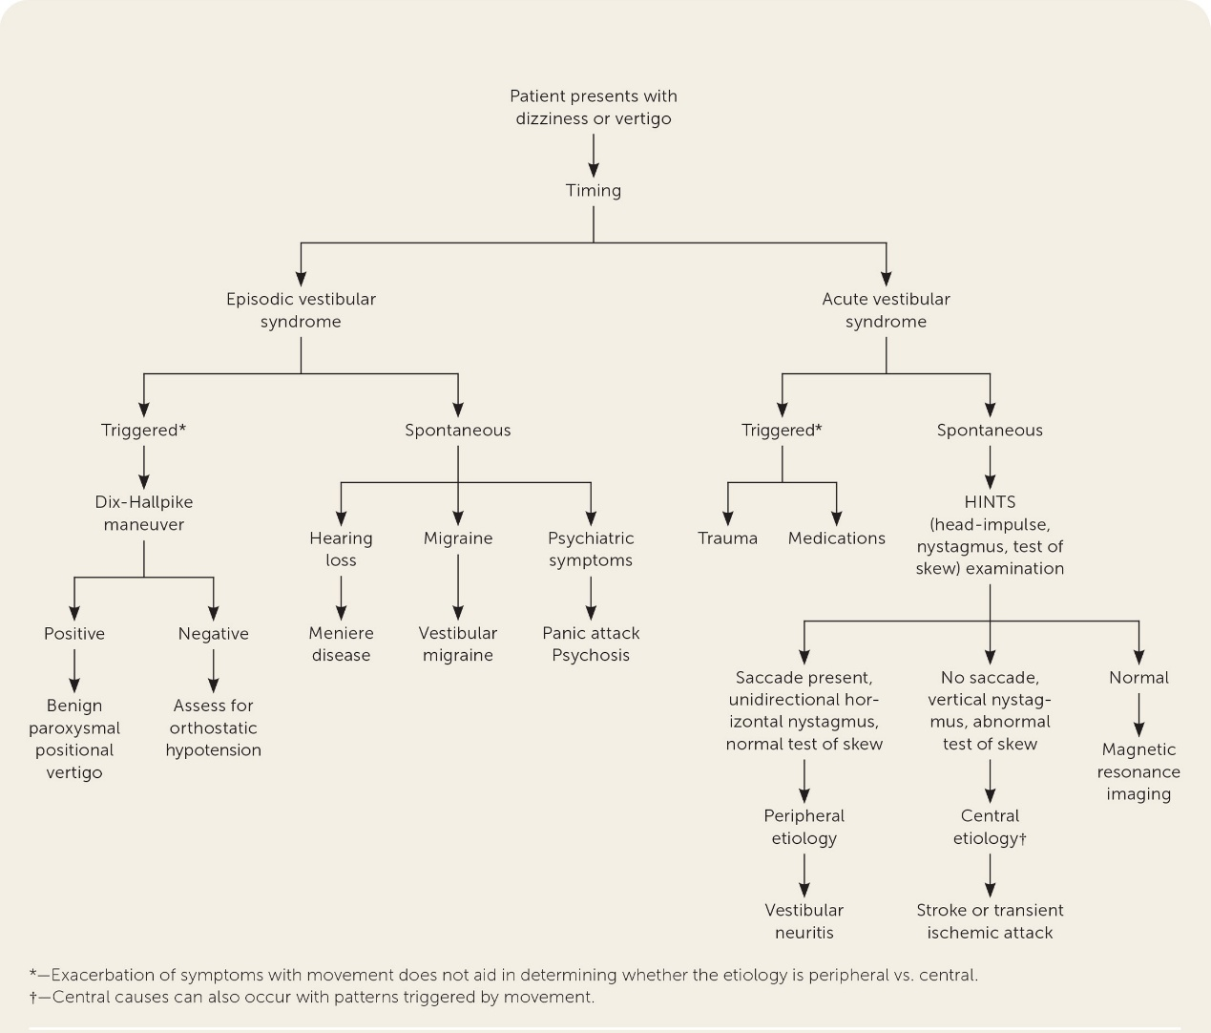Figure 1 Diagnostic evaluation of dizziness. Adapted with permission from Muncie HL, Sirmans SM, James E. Dizziness: Approach to evaluation and management. Am Fam Physician. 2017;95(3):156. undefined
When to Consider Vascular Causes
Carotid imaging is not indicated for positional dizziness because:[7]
- Nonspecific symptoms including vertigo, ataxia, diplopia, dysarthria, syncope, and dizziness are not typically associated with carotid territory thromboembolic events[7]
- Carotid stenosis causes stroke through embolism, not hypoperfusion-related dizziness
- The carotid circulation supplies the cerebral hemispheres, not the vestibular apparatus
Vertebrobasilar insufficiency (VBI) is the relevant vascular consideration for positional dizziness, but it has distinct features:[6][8][9]
- Spontaneous episodes (not just positional), though may be triggered by standing or head rotation
- Multiple posterior circulation symptoms: dizziness PLUS diplopia, dysarthria, ataxia, bilateral weakness, visual field defects, perioral numbness
- Usually continuous rather than brief (<30 seconds) episodes[10]
- Nystagmus that is gaze-evoked, does not fatigue, and is not suppressed by fixation[10]
- Risk factors: elderly, atherosclerotic disease, vertebral artery dissection
Practical Approach to Positional Dizziness
Clinical Feature | BPPV (Peripheral) | Orthostatic Hypotension | Vertebrobasilar Insufficiency | References
Duration | 1 minute | Seconds to minutes upon standing | Usually 30 minutes | [1], [2], [3]
Trigger | Specific head movements | Standing from supine/sitting | Standing, head rotation, or spontaneous | [1], [3], [4]
Associated symptoms | None | Presyncope, visual dimming | Diplopia, dysarthria, ataxia, visual field defects | [1], [5], [6]
Nystagmus pattern | Torsional, fatigable on Dix-Hallpike | None | Gaze-evoked, non-fatiguing | [1], [2]
Response to maneuvers | Resolves with Epley | Resolves lying down | No response to repositioning | [2], [4], [7]
Indications for Vascular Imaging
Consider carotid duplex only if:[7][12]
- Focal hemispheric or retinal symptoms: weakness, sensory loss, aphasia, amaurosis fugax
- Cervical bruit on examination
- Multiple vascular risk factors with concern for atherosclerotic disease
For suspected VBI with positional symptoms plus other brainstem deficits, consider vertebral artery imaging (CTA/MRA of neck), not carotid duplex.[13] However, true positional VBI is rare—one study found only 4 of 14 patients referred for suspected positional VBI had reproducible symptoms with severe posterior cerebral artery flow drops on transcranial Doppler during head rotation.[14]
Bottom Line
For patients with isolated positional dizziness and neck soreness/tightness:
1. Perform Dix-Hallpike maneuver to diagnose BPPV
2. Perform active stand test to diagnose orthostatic hypotension
3. Do not order carotid duplex unless focal hemispheric/retinal symptoms are present
4. Consider vertebral artery imaging only if multiple posterior circulation symptoms suggest VBI
The diagnostic yield of carotid duplex in this population is essentially zero, as positional dizziness is not a manifestation of carotid disease.
Would you like to explore the proper technique for performing and interpreting the HINTS examination to distinguish peripheral from central causes of acute vestibular syndrome?
References
- Diagnosis and Treatment of Benign Paroxysmal Positional Vertigo. Kerber KA, Carender W, Meurer WJ. JAMA. 2026;:2848127. doi:10.1001/jama.2026.1927.
- Benign Paroxysmal Positional Vertigo. Kim JS, Zee DS. The New England Journal of Medicine. 2014;370(12):1138-47. doi:10.1056/NEJMcp1309481.
- Diagnosis and Treatment of Orthostatic Hypotension. Wieling W, Kaufmann H, Claydon VE, et al. The Lancet. Neurology. 2022;21(8):735-746. doi:10.1016/S1474-4422(22)00169-7.
- Management of Orthostatic Hypotension. Moloney D, Youssef A, Okamoto LE. JAMA Internal Medicine. 2026;:2847532. doi:10.1001/jamainternmed.2026.0284.
- Orthostatic Hypotension: A Practical Approach. Kim MJ, Farrell J. American Family Physician. 2022;105(1):39-49.
- Dizziness: Evaluation and Management. Rogers TS, Noel MA, Garcia B. American Family Physician. 2023;107(5):514-523.
- The Society for Vascular Surgery Implementation Document for Management of Extracranial Cerebrovascular Disease. AbuRahma AF, Avgerinos ED, Chang RW, et al. Journal of Vascular Surgery. 2022;75(1S):26S-98S. doi:10.1016/j.jvs.2021.04.074.
- Vertebrobasilar Disease. Savitz SI, Caplan LR. The New England Journal of Medicine. 2005;352(25):2618-26. doi:10.1056/NEJMra041544.
- Posterior Circulation Ischaemic Stroke and Transient Ischaemic Attack: Diagnosis, Investigation, and Secondary Prevention. Markus HS, van der Worp HB, Rothwell PM. The Lancet. Neurology. 2013;12(10):989-98. doi:10.1016/S1474-4422(13)70211-4.
- Clinical Practice Guideline: Benign Paroxysmal Positional Vertigo. Bhattacharyya N, Baugh RF, Orvidas L, et al. Otolaryngology--Head and Neck Surgery : Official Journal of American Academy of Otolaryngology-Head and Neck Surgery. 2008;139(5 Suppl 4):S47-81. doi:10.1016/j.otohns.2008.08.022.
- Orthostatic Hypotension: JACC State-of-the-Art Review. Freeman R, Abuzinadah AR, Gibbons C, et al. Journal of the American College of Cardiology. 2018;72(11):1294-1309. doi:10.1016/j.jacc.2018.05.079.
- 2011 ASA/ACCF/AHA/AANN/AANS/ACR/ASNR/CNS/SAIP/SCAI/SIR/SNIS/SVM/SVS Guideline on the Management of Patients With Extracranial Carotid and Vertebral Artery Disease: A Report of the American College of Cardiology Foundation/American Heart Association Task Force on Practice Guidelines, and the American Stroke Association, American Association of Neuroscience Nurses, American Association of Neurological Surgeons, American College of Radiology, American Society of Neuroradiology, Congress of Neurological Surgeons, Society of Atherosclerosis Imaging and Prevention, Society for Cardiovascular Angiography and Interventions, Society of Interventional Radiology, Society of NeuroInterventional Surgery, Society for Vascular Medicine, and Society for Vascular Surgery. Brott TG, Halperin JL, Abbara S, et al. Journal of the American College of Cardiology. 2011;57(8):e16-94. doi:10.1016/j.jacc.2010.11.006.
- ACR Appropriateness Criteria® Dizziness and Ataxia: 2023 Update. Wang LL, Thompson TA, Shih RY, et al. Journal of the American College of Radiology : JACR. 2024;21(6S):S100-S125. doi:10.1016/j.jacr.2024.02.018.
- Dynamic Transcranial Doppler Assessment of Positional Vertebrobasilar Ischemia. Sturzenegger M, Newell DW, Douville C, Byrd S, Schoonover K. Stroke. 1994;25(9):1776-83. doi:10.1161/01.str.25.9.1776.

